Event Planner

(Uses a hash data structure)

Name**: Ryan Nicoli Ranola** Year & Section: **BSIT 2B**

The Event Planner application console it’s a program that helps users to organize and manage events.

* Add an Event
* View an Event
* Delete an Event
* View All Events
* Exit

**Why did you make that kind of application and how does it contribute to you or to the community?**

I created the Event Planner to practice basic programming skills and understand how to manage data with a hash table. And for the community, it helps the community by providing a simple, easy-to-understand that helps people organize and manage their events more efficiently.

Here’s the screenshot:

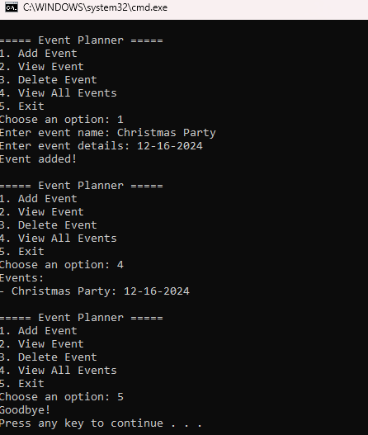

GitHub Username: **ranrynnic**